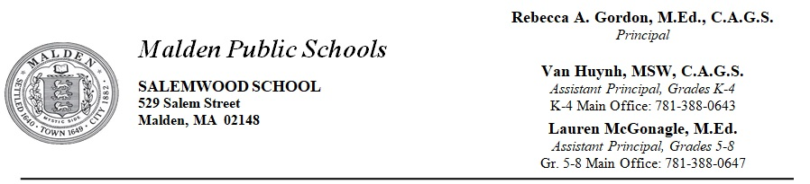

School Council Meeting Notes
March 2, 2018

Members:

Rebecca Gordon, Principal, Co-Chair- Present
Linsey Wyman, Community Member- Absent
Nuria Campos, Parent (kindergarten) - Absent
Miclyna Etienne, Parent (grade 2 & 4) - Absent
Marcia Pereira, Parent (kindergarten)- Present
Amanda Maffeo, Teacher, Co-Chair- Present
Meredith O’Kane, Teacher- Present
Lisa Pastore, Teacher- Present
Alan Rodriguez, Teacher- Present

Notes​ ​taken​ ​by​ ​Meredith O’Kane

I. Feedback on 1st Enrichment Showcase:

A. Great turn out with over 200 families present
B. Recommendation of 8th Grade Student Council members escorting parents/guardians to their child’s Enrichment and to clarify where bathrooms are
C. Time-frame worked well with scheduling and will continue to be in place for the second Enrichment Showcase, which will be on June 8, 2018
D. SIblings and parents seemed to feel engaged and involved, which in turn, caused their child to be invested in the Enrichment

II. Dental Screenings:

- Dental Screenings will be taking place for students on Monday March 5th, and Tuesday March 6th. They must have returned a signed permission slip stating they are allowed to have a free screening and sealants by a visiting dentist and an assistant hygienists to partake.
- These dental teams will be making referrals based upon exams, and students will be called down to the Nurse’s office pending permission slips
- Program offered by the Department of Public Health, and any Classroom/Homeroom teacher who returns permission slips will receive a Target or Starbucks gift card as incentive.

III. Read Across America:

- We celebrate Dr. Seuss’s birthday - March 2, 2018 by creating a week of themes for students and staff to participate in, based upon his books, called Read Across America:
    - Monday - Crazy Socks Day
    - Tuesday - Crazy Hair Day
    - Wednesday - Wacky Wednesday
    - Thursday - Twin Day
    - Friday - Wear your favorite color day

B. This tribute is encouraging participation to the entire school, and as a reminder, Oh The Places You’ll Go is a great read for middle school students and adults!

IV. Youth Risk Behavior Survey

- Tests will be administered to middle school students, online, in the Spring - actual date is TBA.

V. Spring Testing

- April 23, 2018-May 25, 2018 are MCAS testing dates
- MCAS Accommodation meetings taking place this month, as well as Security/Protocol training

VI. March Field Trips

- Kindergarten and First Grade will be attending the North Shore Music Theatre
- Sixth Graders will be attending the Nature’s Classroom Field Trip from March 20, 2018-March 23, 2018
- Eighth Graders will be attending The Museum of Science

Upcoming Meeting​ ​Dates:​

7:00 am. in the library

- April 6, 2018
- May 4, 2018
- June 1, 2018

