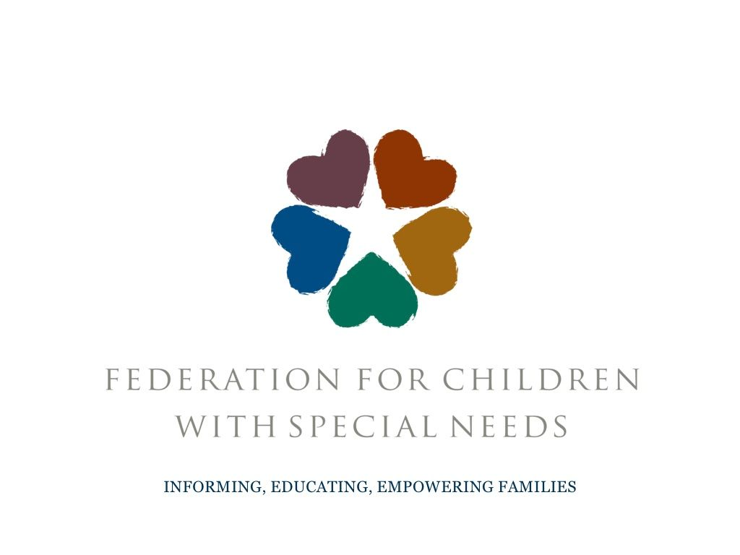
Malden SEPAC
(Special Education Parent Advisory Council)
Invites all parents and caretakers to:

What: Basic Rights: Understanding the IEP presented by Ellen Scoggins, Educational Advocate.
When: Thursday, February 13th 6:30pm-8pm
Where: Forestdale School Library: 74 Sylvan Street, Malden
Contact: MaldenSEPAC@gmail.com

This presentation will delve into the Individual Education Program (IEP) document, its development, the breakdown of each section and understanding how the document will support a student.
Workshop Topics:
Why the IEP is important, who is eligible for an IEP, how the IEP is developed, strengths and concerns, vision statements, IEP sections including PLEP A and B, Annual Goals, and Service Delivery Grid, differences between Accommodations and Modifications, Response, Placement and Consent, Procedural Safeguards and more!

FREE to all.
Light refreshments will be provided.

