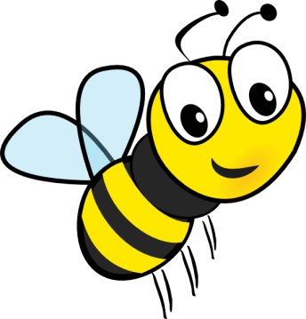
Location | Be Safe | Be a Friend
Hallway | - Hands on own body  - Walking feet  - Stay with the group | - Quiet voice  - Share the hallway  - Kind words
Bathroom | - Wash hands  - Hands on own body  - Wait nicely | - Give privacy  - Flush  - Take Turns
Cafeteria | - Hands on own body/lunch  - Walking feet  - Stay with the group | - Wait your turn  - Quiet voice  - Use kind words
Indoor/Outdoor Playground | - Up the stairs, down the slide  - Safe body  - Toys in their area | - Wait your turn  - Play with everyone  - Use kind words
Gym | - Safe body  - Give space  - Keep toys in their area | - Use kind words  - Make a friend  - Wait your turn
Stairs | - Eyes forward  - Hold the railing  - Hands on your own body | - Follow the arrows  - Quiet voice  - Give space

