BEEBE SCHOOL PARKING
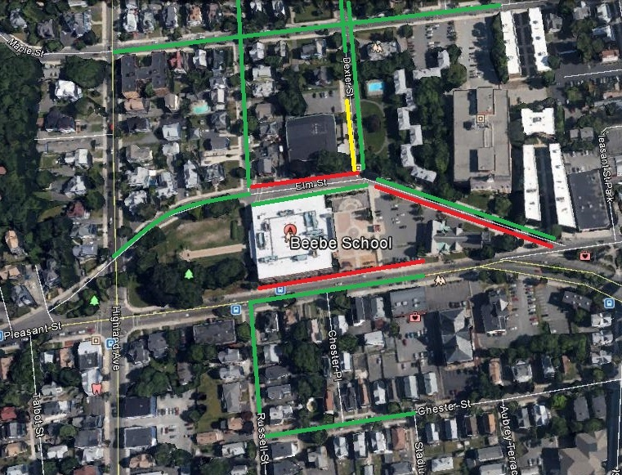
GREEN: PARKING IN “PARKING BY PERMIT ONLY” IS ALLOWED FROM 7:30-9:00AM & 1:30-3:00PM. THIS WILL ALSO BE ACCEPTABLE ON STREET CLEANING DAYS DURING THE TIMES ABOVE.
YELLOW: LIVE PARKING ONLY AND DRIVER MUST STAY IN VEHICLE AT ALL TIMES.
RED: NO PARKING AT ANY TIME WILL BE PERMITTED. THIS ALSO INCLUDES, CROSSWALKS, HANDICAP PARKING, AND FIRE ZONES.

PLEASE NOTE THAT PARKING WILL BE STRICTLY ENFORCED. PARKING HAS BEEN EXTENDED IN THE VARIOUS DIRECTIONS TO ACCOMMODATE YOUR PARKING NEEDS. PLEASE UTILIZE ALL AVAILABLE PARKING TO ENSURE THE SAFETY OF THE STUDENTS, FAMILIES, AND STAFF.

